Functional Requirements Document

Power Distribution Board

Dionysus

[HANNAH]

[July, 2021]

Revision Sheet

|  |  |  |  |
| --- | --- | --- | --- |
| Rev | Description | Author | Date |
| A | RELEASED | J. LENDI | MM/DD/YYYY |
|  |  |  |  |
|  |  |  |  |
|  |  |  |  |
|  |  |  |  |

NOTE TO AUTHOR: Highlighted, italicized text throughout this document is provided solely as background information to assist in creating the document. Please delete such text, as well as the instructions in each section prior to document release.

Table of Contents

Introduction 1

Purpose 1

Scope 1

In Scope 1

Out of Scope 1

Background 1

References and Design Standards 1

Assumptions and Constraints 1

Acronyms and Abbreviations 2

Methodology 3

User Requirements 4

Functional Requirements 5

Interface Requirements 5

Hardware Requirements 5

Power Management Controller 5

System Controller 6

I2C Bus Isolator 6

Peripherals 6

Pulse Width Modulation 7

Real-time Clock 7

Software Requirements 7

Communication Requirements 7

Operational Requirements 7

Input/Outputs 7

Inputs 8

Outputs 8

Security and Privacy 8

Test 9

Cases 9

Procedures 9

Test History 9

Appendix 10

Glossary 11

# Introduction

Provide an overview of the system and some additional information to place the system in context

## Purpose

**Describe the overall purpose. Reference the system name and identifying information about the system to be implemented**

Create a control board that can handle the inputs and outputs required to operate a hydroponic garden system. Today’s microcontrollers and single board computers are not capable of driving all the hardware needed to sustain a hydroponic garden. The control boards are very capable in their computing power and make for a good platform to use. Unfortunately, additional hardware is required.

Rather than having a mess of piggyback boards, modifications, and poor wiring, a single power distribution board will be created to handle the necessary inputs and outputs of a garden.

## Scope

Describe the scope of the document and how it accomplishes its purpose

### In Scope

* Self-contained computing power
* Allow for some IO expansion
* Raspberry Pi 3B+ or Arduino based processor and firmware
* E-stop circuitry

### Out of Scope

* Raspberry Pi Compute Module compatibility
* Raspberry Pi Model 4 compatibility
* Voltage and current feedback measurements on circuits
* True grow light drivers

## Background

What lead to these functions or requirements? Who is producing the document and why?

## References and Design Standards

Provide a list of references that were used, including but not limited to:

Design standards

Industry standards

Research

Controlling documents

## Assumptions and Constraints

Provide a list of contractual or task level assumptions and/or constraints that are preconditions to preparation of the FRD. Assumptions are future situations beyond the control of the project, whose outcomes influence the success of a project.

Examples of assumptions include: availability of a technical platform, legal changes and policy decisions.

Constraints are boundary conditions on how the system must be designed and constructed. Examples include: legal requirements, technical standards, strategic decisions.

Constraints exist because of real business conditions. For example, a delivery date is a constraint only if there are real business consequences that will happen as a result of not meeting the date. If failing to have the subject application operational by the specified date places the organization in legal default, the date is a constraint.

Preferences are arbitrary. For example, a date chosen arbitrarily is a preference. Preferences, if included in the FRD, should be noted as such.

## Acronyms and Abbreviations

Provide a list of acronyms and abbreviations used in this document and the meanings of each

# Methodology

Describe the overall approach used in the determination of the document’s content. Describe the modeling method(s) and how they will be implemented.

# User Requirements

# Functional Requirements

## Interface Requirements

The circuit board interfaces will be screw terminal blocks and header pins.

The board will interface with Atlas Scientific’s EZO system for various sensors and their peristaltic pumps.

The pumps require a 5-pin Molex KK Interconnect System connector for data. The circuit board will have the same connector built in. Each pump can be easily installed with the same harness assembly. For costing reasons, not all five pumps have to be installed. This allows the end user to choose how to implement the devices as they see fit.

LEDs will be used to indicate basic board functions and diagnostics, such as power on, Tx/Rx indicator lights, etc.

* Board power (Vin) on
* Regulated 3.3 volts on
* Regulated 5 volts on
* I2C (SDA and SCL) transmitting
* Main pump relay active
* Feedback pump relay active
* Peristaltic pump interrupt on
* I2C bus isolator power and communication
* Arduino Due LEDs (Tx/Rx, Pwr, LED_Builtin, TXL LED, RXL LED)

## Hardware Requirements

### Power Management

The system processor and microcontroller require 3.3 volt and 5 volt power, but operate at 3.3 volt logic levels. The water pump(s) and reservoir heater activation use a FET to pass input voltage (12-24V) to an AC relay. Flyback protection should be used. The chemical peristaltic pumps and grow lights operate between 12 and 24 volts DC.

Power regulation is required for the board. Power management will consist of voltage regulation for the board’s controller, sensors, and other low power accessories. Four high side drivers will be used to power larger loads connected, such as peristaltic pumps, grow lights, and water pump relay coil activation.

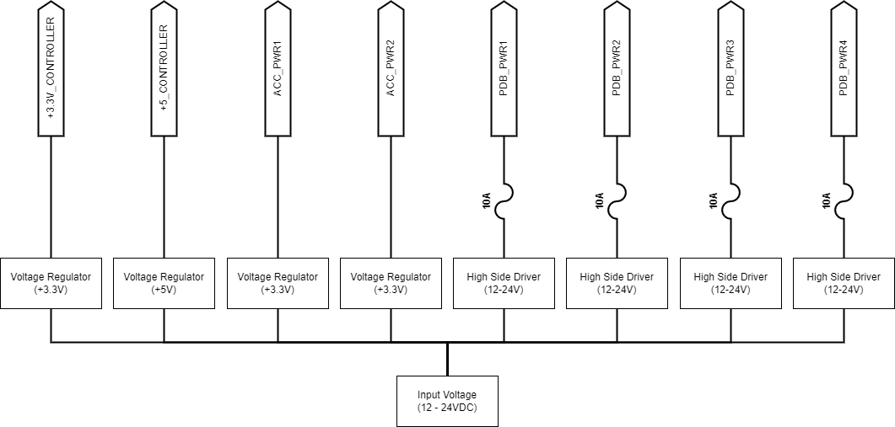

Figure 1: Power Management Block Diagram

The board must be able to take in voltage between 12 and 24 volts DC and supply clean power rails at 3.3V, 5.0V, and input voltage (12-24V). Circuit protections must be enforced.

### System Controller

The system controller will be the ATSM3X8E microcontroller by Microchip Technology. It contains a 32-bit ARM Cortex-M3 processor. Microcontroller circuitry will be based off of the Arduino Due board.

Processor debug and troubleshooting pins must be accessible when board is fully assembled.

Two micro-USB ports will be used. One is for programming the board. The other is for connectivity. Optionally add JTAG connection for troubleshooting.

### Two-Wire Interface Bus Isolator

The Atlas Scientific EZO boards require voltage isolation if multiple boards are used on the same bus. Each EZO board will have a voltage and communication isolator circuit. It uses a two-wire interface (TWI) digital isolator along with an isolated DC/DC converter.

The isolated busses require termination resistors.

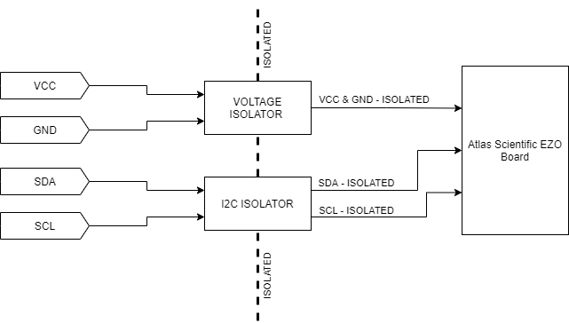

Figure 2: TWI Bus Isolator Block Diagram

### Peripherals

The board must be able to accept and protect additional input/output signals. This includes: temperature sensors, level sensors, enable/disable signals, and various output signals.

3 - Relay activation

3 - Relay feedback

5 - Digital liquid level sensor

5 - Temperature sensor (1-wire digital)

4 – Atlas Scientific EZO boards

### Pulse Width Modulation (PWM) Controller

The grow lights used will be RGB LEDs requiring brightness and color control. A RGB PWM LED driver will be used to drive at least 2 channels of grow lights. Additional channels may be added if space requirements and circuitry permits. Red and blue will be the main colors used.

PWM control will be used to control the brightness of the LEDs. This simulates the rising and setting of the sun.

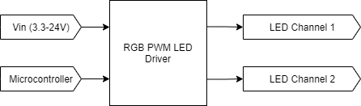

Optional feature would be a way to create sectors of addressable LEDs. This would allow for simulating the sun moving east to west in the sky.

### Real-time Clock

This optional feature would be nice to have for data logging purposes and future product improvements.

### Basic circuit protection

Input/output pins should be protected against short to power and short to ground.

### Temperature Sensors

For the first design iteration, digital 1-wire temperature sensors, Maxim DS18B20, are acceptable. They require no additional hardware or circuitry to operate. The digital communication bus must be scanned on start up to search for all available sensors.

There is no requirement for PCBA temperature sensors.

## Software Requirements

The processor will be programmed with the Arduino Due firmware. Any custom firmware or software should be readily available and accessible to the end user.

## Communication Requirements

The circuit board will be a flexible design for the end user. Some or all of the inputs, outputs, and sensors may be used. Internal communication must be flexible. Therefore, an I2C bus will be used for internal board communication. The EC sensor, pH sensor, flow meter, and peristaltic pumps specified for this project are I2C and UART compatible. UART is simpler in its design but does not allow for the flexibility that an I2C bus does.

The bus will have termination jumpers at various points to allow the end user to select where the bus is terminated.

An external connector will be provided TWI communication to an external board should one be added.

## Operational Requirements

## Input/Outputs

All signal input and outputs

### Inputs

* EC sensor
* pH sensor
* Flow rate
* Temperature sensor (X3)
* Digital liquid level sensor (X6)
* Emergency stop

### Outputs

* LED lights (2 channels)
* Relay activation (X2)

## Security and Privacy

# Test

## Cases

Test cases for verification testing

## Procedures

Methodology for verification testing on machine

## Test History

| ***When*** | ***What*** |
| --- | --- |
| Test Version Number | Completed Testing |
|  |  |

Appendix

Glossary